UK Gender Pay Statement
At Currie & Brown, we are committed to creating a workplace where fairness, equity and opportunity are embedded in how we operate every day. When people are supported to succeed based on their talent and contribution, we build stronger teams, deliver better outcomes for our clients, and create a more resilient business.
As an independent, global organisation built on expertise and collaboration, inclusion is fundamental to how we work. Diverse perspectives strengthen our decision-making, improve performance and help us deliver better outcomes for our clients and the communities we serve.
We are committed to transparency in reporting our gender pay data and to holding ourselves accountable for continued progress. We regularly review our practices, challenge barriers to progression, and take practical, measurable action to improve gender balance at all levels of our business.
We know there is more to do. By maintaining focus and momentum, we strengthen not only our performance, but the positive impact we make as a business.

Alan Manuel, Group CEO Currie & Brown
March 2026

What is the gender pay gap?
The gender pay gap is the difference between the average pay of men and women in an organisation (Gender Pay Gap, UK Government). It does not compare the pay of people doing the same job.

How does the gender pay gap differ to equal pay?
The gender pay gap and equal pay are not the same thing. The gender pay gap measures the difference in average pay between all men and women across an organisation, regardless of their roles.

Table 1: Analysis of technical staff at Currie & Brown
Job level | Earnings % | % of female headcount
Assistant | The average pay of females is 5% more than males | 31%
Professional | The average pay of males is 10% more than females | 34%
Senior professional | The average pay of males is 5% more than females | 23%
Associate | The average pay of males is 3% more than females | 24%
Associate director | The average pay of females is 4% more than males | 15%
Director | The average pay of males is 1% more than females | 12%
Senior director | The average pay of females is 8% more than males | 6%
Previous years’ figures can be found here: Gender pay gap reporting: guidance for employers - GOV.UK

Gender pay gap analysis at Currie & Brown
The underrepresentation of women is an issue across our industry and RICS data suggests that only 20% of qualified staff in our industry around the globe are female.¹ This wider industry imbalance directly impacts the talent pipeline and progression into senior roles. At Currie & Brown, we are committed to ensuring diversity and addressing the current gender imbalance as a means of eliminating any gender pay gaps wherever they exist across our organisation.
Within our business, our current percentage of female technical staff has risen from 22% to 23%, reflecting further positive progress since last year. While we are proud of this progress, women are still under-represented—especially in senior technical roles—which is the cause of the gender pay gap.
We are pleased to see continued year-on-year progress across our UK business, with a clear reduction in both the mean and median hourly pay gap between men and women. Over the past 12 months, the gap has narrowed in particular at Associate and Associate Director levels. We believe this progress reflects our sustained focus on developing our people, planning for future roles, creating inclusive career pathways, recruiting more women, and supporting the growth of female talent and leadership at Currie & Brown.
Assistant level
The average pay of females at Assistant level is 5% higher than for men, reflecting our commitment to supporting early careers and reducing barriers for female talent. We are continuing to increase the number of women joining the construction industry at graduate and apprentice level by actively supporting their career development. This commitment is recognised through our Platinum membership of The 5% Club.
Professional level
At Professional level, the gender pay gap is 10% higher for men. This is partly due to the lower number of female chartered surveyors at this stage in their career. We are working to address this by increasing the support we make available for women to undertake their APC through our graduate programme.
Associate level and above
Men earn slightly more than women at Associate level. And at Associate Director level, women earn slightly more. We reward our employees fairly based on the roles they perform and contributions they bring irrespective of gender. We are continuing to strengthen our recruitment practices to ensure we attract and appoint people to senior roles in a fair and balanced way. This helps improve gender balance at the top of our organisation and reinforces our commitment to creating an inclusive workplace.
1 RICS latest data

Gender pay gap key data
Ordinary/hourly pay | The mean female GPG in hourly pay as a % of men’s pay has decreased from 23% to  19% | The median female GPG in hourly pay as a % of men’s pay has decreased from 28% to  22%
Bonus pay gap | Percentage of females who were paid bonuses has increased by 2% to  8% | Percentage of males who were paid bonuses has also increased from 8% to  15%
 | The mean female bonus is  1%  lower than men’s | The median female bonus is  45%  higher than men’s
 | Alongside an increase in the number of women becoming part of the bonus pool, the gap in mean bonus payments between males and females has reduced from 22% to 1%, reflecting our consistent approach to reward. The median bonus received by women is 45% higher than men, although this is partly due to fewer women than men being part of the bonus pool.
  Quartile pay bands | 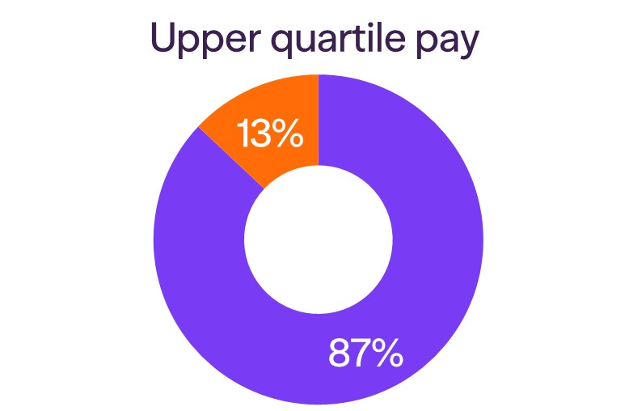 | 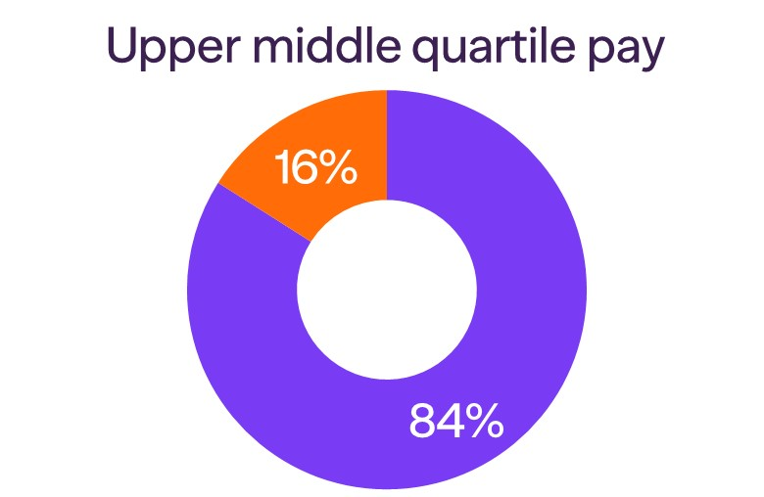
 | 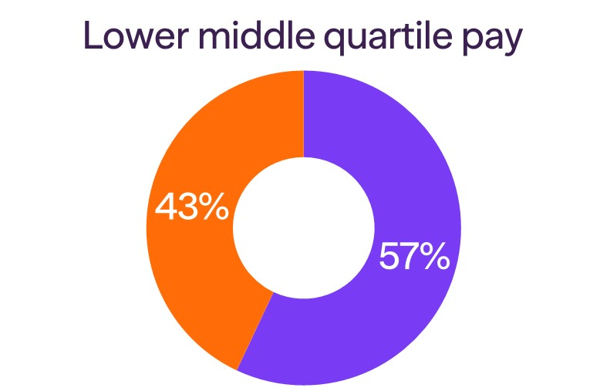 | 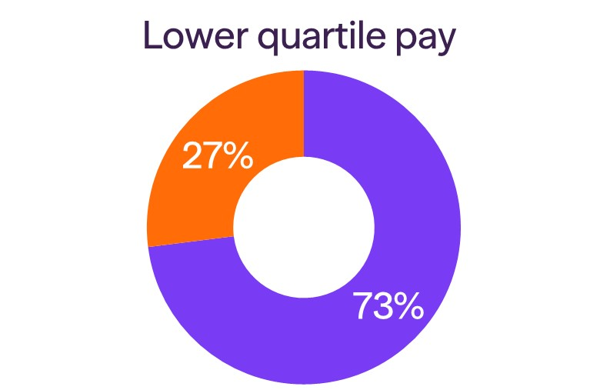

Addressing underrepresentation in our industry
At Currie & Brown, we’re making strides towards improving diversity. Women now make up 31% of our global workforce, which is significantly higher than the industry average of 20%. While we are proud of this progress, we recognise that there is still more to do. We remain committed to reducing our gender pay gap year on year by increasing female representation at all levels of our business, particularly in senior roles.
Additionally, we actively promote diversity across our profession and work to tackle the underrepresentation of women in the industry through a range of initiatives. These include:
- Policies: We ensure all policies, documentation and procedures are free from gender bias, explicitly and implicitly ensuring they remain compliant with current legislation and best practice—from the introduction of menopause policies to enhanced family-friendly benefits.
- Recruitment: We continue to engage with schools, colleges and universities to encourage and inspire more young women to consider careers in our industry.
- Development programmes: Our leadership development programmes continue to support women to build skills and progress their careers at Currie & Brown.
- Working groups: We have established groups at both global and local levels to promote equality, diversity and inclusion across our business.
- Commitment to wellbeing: By committing to and adopting the standards of the Workplace Wellbeing Charter, we foster an inclusive environment that supports women’s mental and physical wellbeing, helping to improve retention, engagement and long-term career progression.
- Diverse promotion panel: We have clear and transparent criteria for progression designed to ensure that the promotion process is fair and equitable. Our panels are diverse, with female representation at all interviews to promote fairness and balanced decision-making.

